Logging Into Moodle
To log in to Moodle, first you must sign in to the myNSU website. myNSU Login
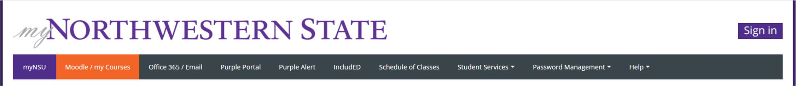

Click on the Sign in button.
Sign in using your NSU email address and password.

Click on the Sign in button.
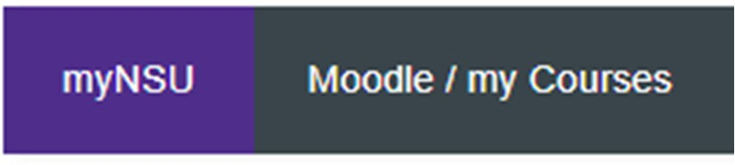
Sign in using your NSU email address and password.
Once you have signed in, click on Moodle / my Courses to go to the Moodle Dashboard.

My Courses provides a list of courses. To view courses for the current semester, use the filter below Course Overview and choose “In progress.”
To enter a course, click on the course name.
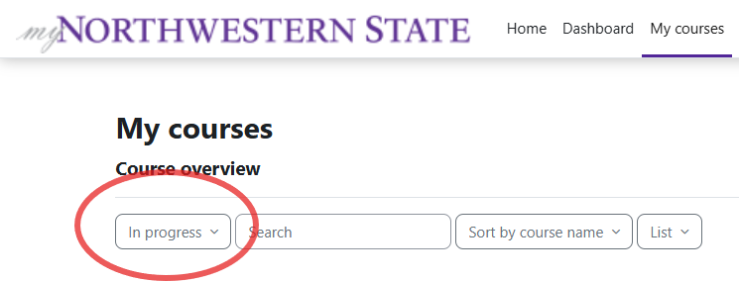
Moodle v. 4.5.7 Updated 03/26

